LAB EXPERIMENT RECORD

Set 12: Website Traffic Analysis

Field | Details
Department | AI&DS
Course Code / Course Name | DSA0602/ Data Handling and Visualization
Experiment | Data Visualization using R
Name | P.Mohith Kumar Reddy
Register Number | 192524223
Date | 06 October 2026
Day | Tuesday

Aim

To analyse website traffic data using a line chart, a bar chart and a data table in R, and to build an interactive dashboard that combines them.
Dataset: Website Traffic

Date | Page Views | Click-through Rate
2023-01-01 | 1500 | 2.3%
2023-01-02 | 1600 | 2.7%
2023-01-03 | 1400 | 2.0%

PROGRAM 1: Line Chart of Daily Page Views

Create a line chart to visualize the trend in daily page views over time. Label the axes and title the chart.
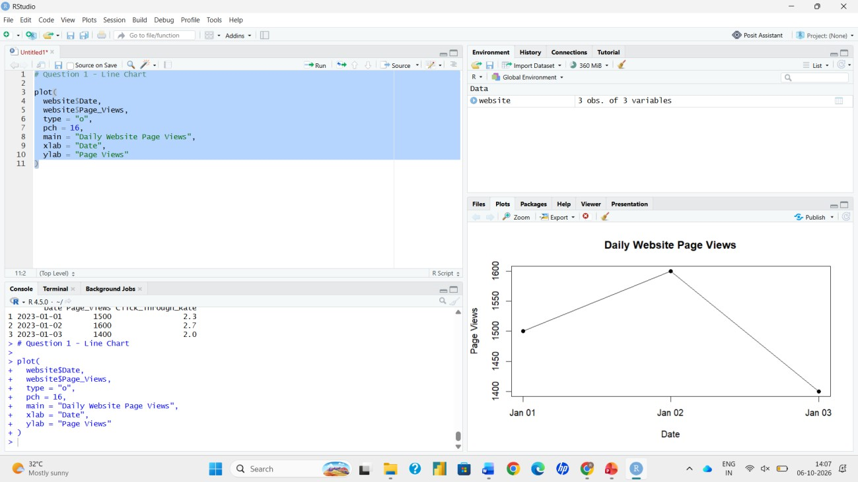
# Dataset
traffic <- data.frame(
Date = as.Date(c("2023-01-01", "2023-01-02", "2023-01-03")),
PageViews = c(1500, 1600, 1400),
CTR = c(2.3, 2.7, 2.0)
)

# Line Chart
plot(traffic$Date, traffic$PageViews, type = "o",
xlab = "Date",
ylab = "Page Views",
main = "Daily Page Views Over Time", col = "blue")

Output 1: Daily Page Views Line Chart

PROGRAM 2: Bar Chart of Top N Days by Click-through Rate

Generate a bar chart showing the top N days with the highest click-through rates. Label the chart elements.
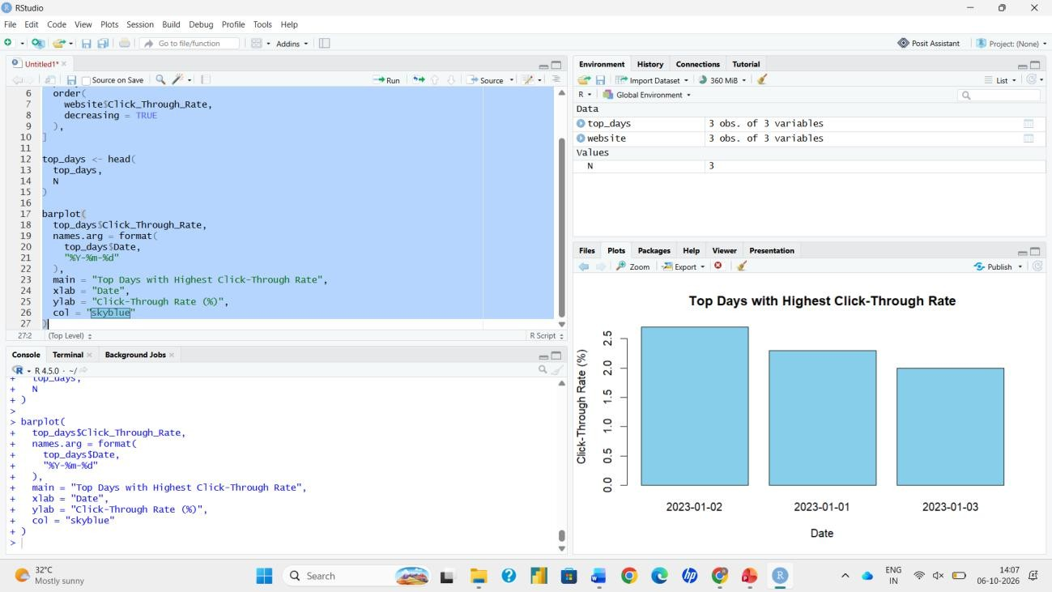
# Choose N N <- 3

# Select the top N days by CTR
top_days <- head(traffic[order(-traffic$CTR), ], N)

# Bar Chart barplot(top_days$CTR,
names.arg = format(top_days$Date), xlab = "Date",
ylab = "Click-through Rate (%)",
main = paste("Top", N, "Days by Click-through Rate"), col = "orange")

Output 2: Top N Days by Click-through Rate

PROGRAM 3: Website Traffic Table

Build a table to show the website traffic data for each day. Label the table elements.
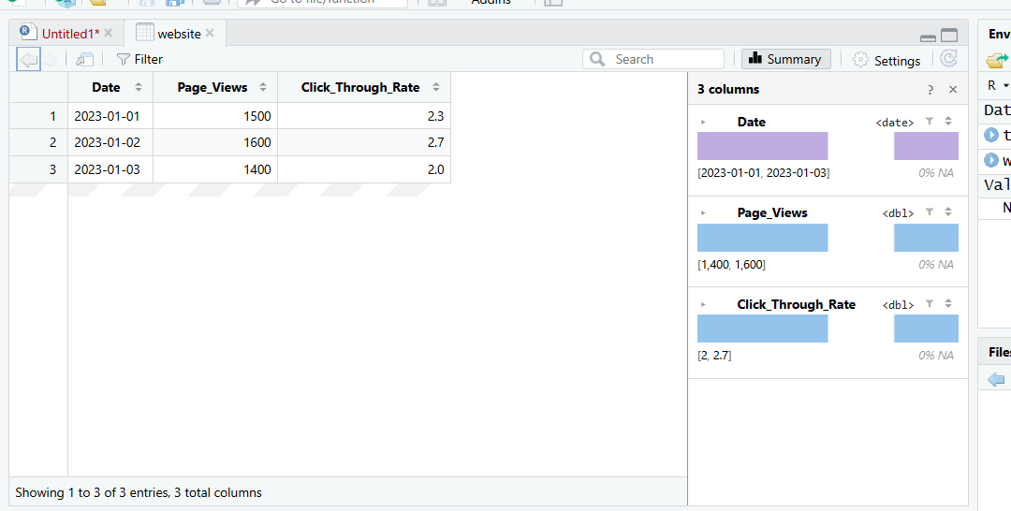
colnames(traffic) <- c("Date", "Page Views", "Click-through Rate (%)") print(traffic)
View(traffic)

Output 3: Website Traffic Table

PROGRAM 4: Interactive Shiny Dashboard

Build an interactive dashboard combining the line chart, bar chart and the table using the Shiny package.
library(shiny)

traffic <- data.frame(
Date = as.Date(c("2023-01-01", "2023-01-02", "2023-01-03")),
PageViews = c(1500, 1600, 1400),
CTR = c(2.3, 2.7, 2.0)
)

ui <- fluidPage(
titlePanel("Website Traffic Dashboard"), sidebarLayout(
sidebarPanel(
sliderInput("N", "Top N days by Click-through Rate:", min = 1, max = nrow(traffic), value = 3, step = 1)
),
mainPanel( plotOutput("line"), plotOutput("bar"), tableOutput("tbl")
)
)
)

server <- function(input, output) { output$line <- renderPlot({
plot(traffic$Date, traffic$PageViews, type = "o", xlab = "Date", ylab = "Page Views",
main = "Daily Page Views Over Time", col = "blue")
})
output$bar <- renderPlot({
top_days <- head(traffic[order(-traffic$CTR), ], input$N) barplot(top_days$CTR, names.arg = format(top_days$Date),
xlab = "Date", ylab = "Click-through Rate (%)",
main = paste("Top", input$N, "Days by Click-through Rate"), col = "orange")
})
output$tbl <- renderTable({ d <- traffic
d$Date <- format(d$Date)
colnames(d) <- c("Date", "Page Views", "Click-through Rate (%)") d
})
}

shinyApp(ui = ui, server = server)

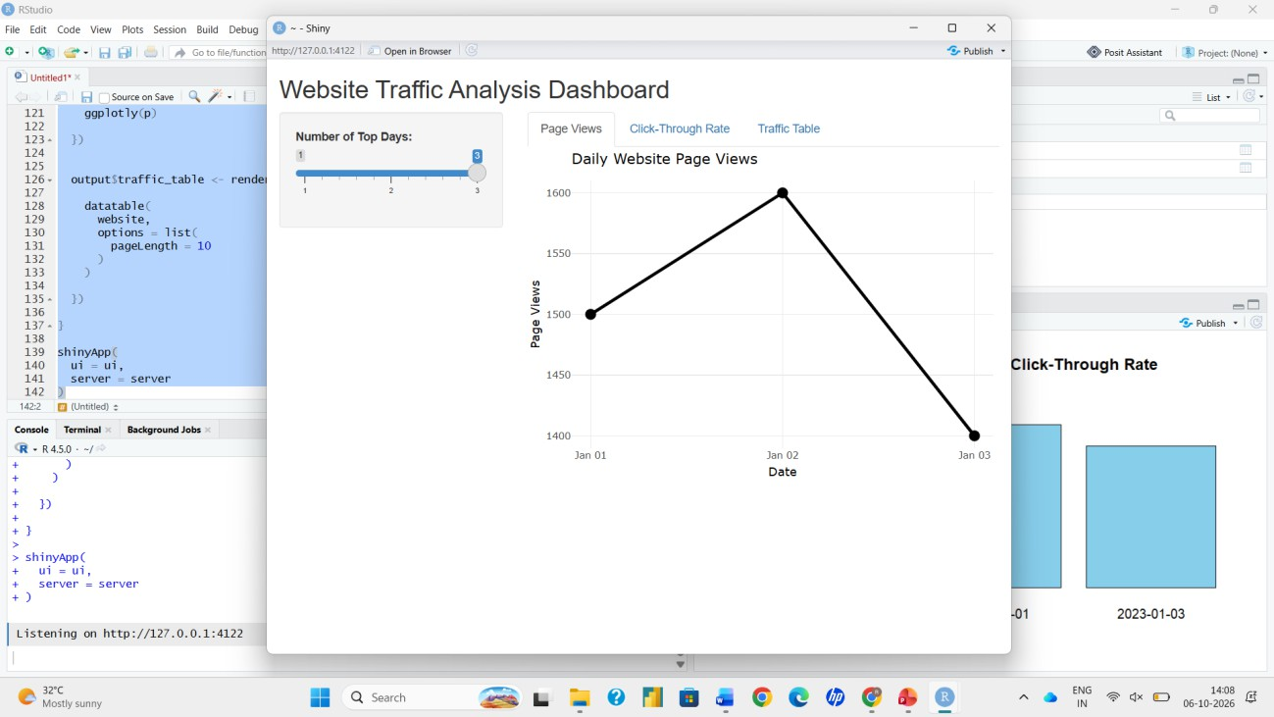
Output 4: Interactive Dashboard

